OBSERVATION TASK 2

Field | Details
Course | Full Stack Web Development
Course Code | 23CM4121
Experiment No. | Task 2
Student Name | V Cherishma
Roll No. | A24126552126
Date | 30-08-2026

TITLE
Dynamic Student Profile Generator Using JavaScript Classes and DOM Manipulation

AIM
To create a JavaScript application that uses a class to represent a student, accepts user input through a form, and dynamically generates and displays the student's profile on the webpage using DOM manipulation.

OBJECTIVE
The objectives of this experiment are:
  - To define a JavaScript class with properties such as Name, Roll Number, Department and CGPA.
  - To create an object of the class using user-provided values.
  - To select DOM elements using getElementById().
  - To handle a button click event using addEventListener().
  - To dynamically create HTML elements using createElement() and set their content.
  - To add the dynamically created elements to the webpage using appendChild().
  - To apply basic CSS styling to the dynamically generated profile.

THEORY
A JavaScript class is a template for creating objects that bundle related data (properties) and behavior together. The constructor() method runs automatically when a new object is created with the new keyword, and it is used to initialize the object's properties from the arguments passed to it.
The Document Object Model (DOM) represents an HTML page as a tree of objects that JavaScript can read and modify. Methods such as document.getElementById() are used to select a specific element from this tree, while properties like .value read the current content of an input field.
Elements can also be created entirely from JavaScript using document.createElement(), which returns a new, unattached element. Its text can be set using the textContent property, and it is inserted into the visible page using parentElement.appendChild(childElement).
Event handling connects user actions to code. button.addEventListener("click", callback) registers a function that runs every time the button is clicked, allowing the page to react to user input without reloading.
In this experiment, these concepts are combined: a Student class stores the entered details as an object, and a click event handler reads the input values, creates the object, and builds the profile display dynamically using DOM methods.

ALGORITHM / PROCEDURE
  - Create an HTML file with input fields for Name, Roll Number, Department and CGPA, a Display button, and an empty container for the profile.
  - Link an external CSS file to style the form and profile container.
  - Link an external JavaScript file to the HTML page.
  - Define a Student class with a constructor that accepts name, rollNumber, department and cgpa.
  - Select the Display button using document.getElementById().
  - Attach a click event listener to the button using addEventListener().
  - Inside the event handler, read the values of all input fields using .value.
  - Create a new Student object using the values read from the form.
  - Select the profile container element and clear any previous content.
  - Dynamically create heading and paragraph elements using createElement().
  - Set the text content of each created element using the student object's properties.
  - Append all created elements to the profile container using appendChild().
  - Open the HTML file in a browser, enter sample student details, and click the button.
  - Verify that the profile is displayed correctly and repeat with different input values.

PROGRAM

index.html
<!DOCTYPE html>
<html>
<head>
<title>Student Profile</title>

<!-- Link CSS file -->
<link rel="stylesheet" href="style.css">
</head>

<body>

<div class="container">

<h1>Student Profile</h1>

<input type="text" id="name" placeholder="Enter Name">
<input type="text" id="roll" placeholder="Enter Roll Number">
<input type="text" id="department" placeholder="Enter Department">
<input type="number" id="cgpa" step="0.01" placeholder="Enter CGPA">

<br>

<button id="displayBtn">Display Student Profile</button>

<div id="profile"></div>

</div>

<!-- Link JavaScript file -->
<script src="script.js"></script>

</body>
</html>

style.css

body {
font-family: Arial, sans-serif; background-color: #f2f2f2;
text-align: center; padding: 30px;
}

.container {
background-color: white; width: 400px;
margin: auto; padding: 25px; border-radius: 10px;
box-shadow: 0 0 10px gray;
}

input {
width: 90%; padding: 10px; margin: 8px;
}

button {
padding: 10px 20px; background-color: blue; color: white;
border: none; border-radius: 5px; cursor: pointer;
}

#profile {
margin-top: 20px; padding: 20px;
background-color: #e8f0fe; border-radius: 10px;
text-align: left;
}

#profile h2 {
text-align: center;
}

script.js
class Student {

constructor(name, rollNumber, department, cgpa) { this.name = name;
this.rollNumber = rollNumber; this.department = department; this.cgpa = cgpa;
}
}

// Select button using DOM
const button = document.getElementById("displayBtn");

// Event handling button.addEventListener("click", function () {

// Get values from input fields
let name = document.getElementById("name").value; let roll = document.getElementById("roll").value;
let department = document.getElementById("department").value; let cgpa = document.getElementById("cgpa").value;
// Create Student object let student = new Student(

name, roll, department, cgpa
);

// Select profile area
let profile = document.getElementById("profile");

// Clear previous content profile.innerHTML = "";

// Create elements dynamically
let heading = document.createElement("h2"); heading.textContent = "Student Profile";

let nameElement = document.createElement("p"); nameElement.textContent = "Name : " + student.name;

let rollElement = document.createElement("p"); rollElement.textContent = "Roll No : " + student.rollNumber;

let departmentElement = document.createElement("p"); departmentElement.textContent =
"Department : " + student.department;

let cgpaElement = document.createElement("p"); cgpaElement.textContent = "CGPA : " + student.cgpa;

// Add elements to webpage profile.appendChild(heading); profile.appendChild(nameElement); profile.appendChild(rollElement); profile.appendChild(departmentElement); profile.appendChild(cgpaElement);
});

CODE EXPLANATION

Code | Explanation
class Student | Defines a blueprint for a student object with name, rollNumber, department and cgpa properties.
constructor() | Initializes a new Student object's properties when it is created with new.
document.getElementById() | Selects a single DOM element by its id attribute, e.g. the button or an input field.
.value | Reads the current text entered by the user in an input field.
addEventListener("click", fn) | Registers a function to run whenever the button is clicked (event handling).
new Student(...) | Creates an object of the Student class using the values read from the form.
document.createElement() | Creates a new HTML element (e.g. <h2> or <p>) that is not yet part of the page.
.textContent | Sets or reads the visible text inside an element.
appendChild() | Inserts a created element into the page as a child of another element (the profile container).
innerHTML = "" | Clears any previously displayed profile before showing the new one.

TEST CASES AND EXECUTION DATA
Each test case was executed by entering the given values into the form and clicking the Display Student Profile button.

Test Case | Name | Roll No. | Department | CGPA | Expected Result | Status
TC-01 | Ravi Kumar | A23126552001 | CSE (AI & ML) | 8.42 | Profile displayed with entered details | Pass

Test Case | Name | Roll No. | Department | CGPA | Expected Result | Status
TC-02 | Priya Sharma | A23126552002 | CSE (Data Science) | 9.10 | Profile updates to new details | Pass
TC-03 | Arjun Singh | A23126552003 | ECE | 7.55 | Profile displayed correctly | Pass
TC-04 | Kiran Reddy | A23126552004 | CSE (Cyber Security) | 0.00 | Profile displayed with  0.00 CGPA | Pass

Additional Validation Test

Test Case | Input | Expected Result | Status
TC-05 | All fields left empty, button clicked | Profile is generated with blank values (no fields are marked required) | Pass

OUTPUT

Output 1: Student Profile Form
The webpage displays a styled container with input fields for Name, Roll Number, Department and CGPA, and a "Display Student Profile" button.
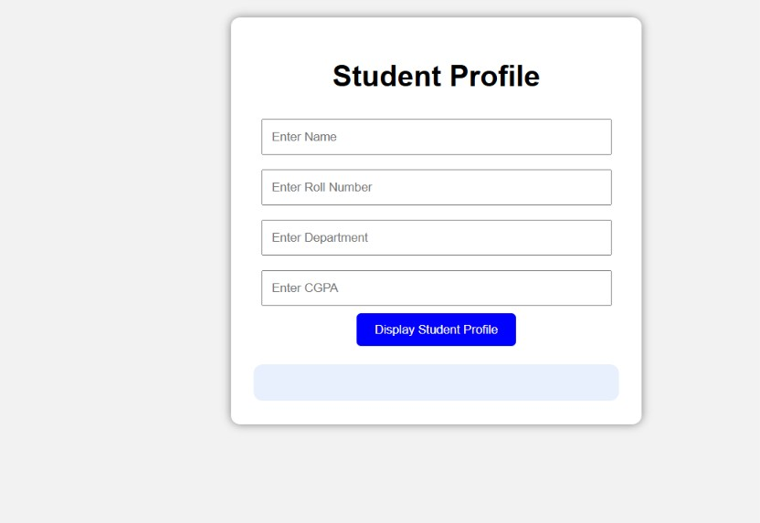

Output 2: Generated Profile
After entering the details and clicking the button, a profile section is dynamically created below the form showing the entered student details.

RESULT
Thus, a JavaScript application was successfully developed that defines a Student class, creates an object from user-entered form data, and dynamically generates and displays the student's profile on the webpage using DOM manipulation and event handling. The application was verified using multiple test cases.

